White-Box Techniques

What is White-Box Techniques
# Source: Chatgpt (GPT-5-Standard) at [8/16/2025]
White-Box Techniques (also called structural testing techniques) are software testing methods that focus on the internal structure, design, and implementation of the code rather than just the outputs.
In white-box testing, testers have full knowledge of the source code and use this to design test cases that verify whether the program logic is working as intended.

🔑 Key Points:
# Source: Chatgpt (GPT-5-Standard) at [8/16/2025]
- "White-box" means looking inside the system (like looking into a transparent box).
- Tests are designed based on control flow, data flow, statements, branches, and paths in the code.
- Goal: Ensure all parts of the code are executed and verified.

✅ Common White-Box Techniques:
# Source: Chatgpt (GPT-5-Standard) at [8/22/2025]
- Statement Testing & Coverage
  - Ensures every line of code is executed at least once.
- Decision (Branch) Testing & Coverage
  - Ensures each decision (e.g., if/else) evaluates to true and false at least once.
- Condition Testing
  - Ensures each boolean condition in a decision takes all possible outcomes.
- Multiple Condition Coverage
  - Tests all possible combinations of conditions in a decision.
- Path Testing / Path Coverage
  - Ensures all possible execution paths in the program are tested.
- Loop Coverage ✅
  - Ensures loops are executed zero, one, and multiple times.
- Data Flow Testing
  - Focuses on how variables are defined, used, and killed (end of scope).

🔍 Example:
# Source: Chatgpt (GPT-5-Standard) at [8/16/2025]
If you have a function:
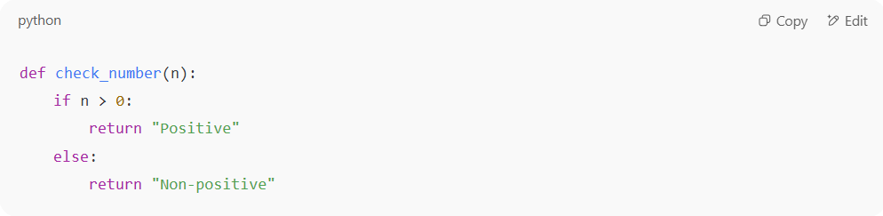
def check_number(n):
if n > 0:
return "Positive"
else:
return "Non-positive"

- Statement Testing: Both lines (return "Positive" and return "Non-positive") must execute at least once.
- Decision Testing: The condition n > 0 must be tested with both True and False.

👉 In short:
White-box techniques = testing how the code works internally, ensuring complete structural coverage, not just functional correctness.

Value of White-Box Testing
# Source: Chatgpt (GPT-5-Standard) at [8/16/2025]
White-box testing is valuable because it ensures internal correctness of the code in addition to just external functionality.

🔑 Key Values:
# Source: Chatgpt (GPT-5-Standard) at [8/16/2025]
- Thorough Verification of Code Logic
  - Ensures all statements, decisions, conditions, and paths are tested.
  - Reduces the chance of hidden logic errors.
- Early Defect Detection
  - Since it requires knowledge of the source code, many defects (like logic errors, unreachable code, incorrect loops, or variable misuse) can be caught before system integration.
- Improves Code Quality & Reliability
  - Encourages developers to write cleaner, more structured, and testable code.
  - Increases confidence that the code works as expected.
- Ensures Maximum Coverage
  - White-box techniques (statement, decision, path, data flow) provide measurable coverage metrics, so testers know exactly how much of the code has been tested.
- Optimizes Code
  - Helps identify dead code, redundant logic, or unnecessary complexity.
  - Supports refactoring and performance improvements.
- Supports Security Testing
  - Attack-prone areas in the logic (e.g., unchecked inputs, insecure loops, poor error handling) can be detected early.
- Complements Black-Box Testing
  - Black-box tests verify functionality against requirements, while white-box ensures that the internal structure is correct. Together, they give stronger overall test coverage.

✅ Example of Value in Action:
# Source: Chatgpt (GPT-5-Standard) at [8/16/2025]
Imagine a banking system:
- Black-box testing confirms: “I can transfer $100 successfully.”
- White-box testing confirms: “All internal conditions, paths, and loops in the transfer function (like overdraft, negative balance, fee calculation) work correctly and securely.”
Without white-box, a hidden bug in a rarely executed branch could cause a financial error.

⚖️ Summary:
# Source: Chatgpt (GPT-5-Standard) at [8/16/2025]
The value of white-box testing = higher confidence, stronger coverage, early detection of logic/security flaws, and overall better code quality.

